INTELLIGENT MARINE TRAFFIC SIMULATOR FOR CONGESTED WATERWAYS

Kazuhiko Hasegawa*, Go Tashiro**, Seiji Kiritani***,
Koji Tachikawa****

* Department of Naval Architecture and Ocean Engineering, Graduated School, Osaka University, 2-1 Suita, Osaka, Japan, hase@naoe.eng.osaka-u.ac.jp
** Communication Systems Business Division, Mitsubishi Electric Corporation, 1-1, Tukaguchihonmachi 8, Amagasaki, Hyogo, Japan
*** Planning & Development Department, Horiba Corporation, 2 Miyanohigashicho, Kisshoin, Minami-Ku, Kyoto-city, Kyoto, Japan, kiritani@horiba.co.jp
**** Control Systems Department, Hitachizosen Corporation, 7-89, Nanko Kita 1, Suminoe-Ku, Osaka, Japan, tachikaw@ompel.hq.hitachizosen.co.jp

Abstract. For the purpose of re-configuration or re-design of marine traffic system, intelligent marine traffic simulator was developed. This is a tool to evaluate marine traffic for any configuration of sea area, lanes and traffic conditions. It includes the modeling of human operator, each vessel will automatically navigate according to her original mission as well as collision avoidance manoeuvres, if necessary. It will be easily evaluated using this simulator how much degree the safety will change according to any change of traffic system, traffic quantity and quality, change of navigational area including addition of ports and cross-ocean bridges etc. The example was shown how traffic control will work in a specified sea area. Marine ITS is a 5-years-project starting from 2000 in Japan. It will target the new marine traffic system. Combining GPS(Global Positioning System), AIS(Universal Automatic Identification System) , satellite or mobile communication and Internet, a proposal of virtual radar system as a future marine traffic system was done.

Key Words. Intelligent control, Automatic navigation system, Traffic simulation, Collision avoidance, Traffic control, Modelling of human operator, AIS, GPS, ITS

- INTRODUCTION

Traffic system simulation was mostly treated as a queuing system and done discretely to solve various problems of logistics in the areas of scheduling, resource utilization, capacity constraints and inventory management. For safety evaluation or precise qualitative estimation, so-called micro or semi-micro simulation system is installed and some include even drivers’ model as well as vehicle dynamics (Ludmann[1]).

In the case of marine traffic, problem is more sophisticated. There are, generally, no fixed lanes and traffic lights. Ships are not equipped with winkers nor a brake. There exists mixture of various vessels from the VLCC (Very Large Crude-oil Carrier) to a row boat. Sometimes, fishing vessels are just on the mission in the sea. Most prosperous fishing area sometimes coincides with most vessels pass. It is just figuratively compared as a combine and a three-wheeler crossing the highway with brake-failed tank trucks. Thus some tragic casualties occur in the sea. Furthermore, if a VLCC collides with another vessel or is agrounded, oil spill suffers many fishing people, wild lives and the environment. The improvement of marine traffic system is urgently requested.

In Japan, a research project called “Marine ITS” is carried out from FY2000 for 5 years by Ministry of Land, Infrastructure and Transport(MLIT). It is roughly divided next three fields: Automatic collision and grounding avoidance system, advanced marine traffic control system, and harbour manoeuvring and berthing/deberthing supporting system. In this paper the second subject is introduced. For this subject, we have developed the Intelligent Marine Traffic Simulator, a tool for marine traffic simulation. It is a macro simulation system including ship dynamics and captain’s modeling with automatic traffic flow generator. We have evaluated an alternative traffic control plan with present status in an existing congested waterway, using this tool.

As the second step of the subject, we have proposed another navigation supporting system. It is called virtual radar or virtual VTS (Vessel Traffic Service) system, utilizing GPS (Global Positioning System), AIS (Universal Automatic Identification System) and Internet. The simulation system wad developed and equipped in the Intelligent Marine Traffic Simulator. Some example of the simulation was shown.

As a result, we have convinced that the Intelligent Marine Traffic Simulator is a useful tool for planning any marine traffic system and its evaluation.

- INTELLIGENT MARINE TRAFFIC SIMULATOR

2.1 Ship Auto-navigation Fuzzy Expert System (SAFES)
Ship Auto-navigation Fuzzy Expert System (SAFES) (Hasegawa, 1993[10]) is the base system of the Intelligent Marine Traffic Simulator. It can be applied for any configuration of waterways and any number of ships. As the system include a captain’s model, it will instruct each ship to follow her mission including collision/grounding avoidance manoeuvres. In this system multi-agent problem and conflict decision-making are solved by expert system and instruction was done by fuzzy reasoning/control. To realize the traffic simulation, the following procedure is used.

- Set destination and departure gates/ports of each ship according to the statistics
- Determine the creation or deletion of each ship according to the arrival time or finish of the task
- Set route including waypoints for each ship
- Set parameters of each ship
- Determine the steering instruction according to the each ship task as well as target ship’s positions and behaviours
- Calculate ship velocity and position according to the instruction
- Proceed one step time

Repeat items (2) to (7) until the end of the simulation time

2.2 Marine Traffic Simulation System (SMARTS)

The Ship-with-a-captain MARine Traffic Simulationsystem (SMARTS) (Hasegawa, 1990[9]) was developed using SAFES. It can automatically create marine traffic flow according to the statistical data. To realize traffic simulation, the following procedure is used.

2.3 Intelligent Marine Traffic Simulation in Osaka
Bay
In this paper the simulation is applied for Osaka Bay. Osaka Bay is one of the most congested areas in Japan and in the world as well as Tokyo Bay. In Osaka Bay, there are many small ports. Authors have categorized these ports to 6 for simplification. The statistical data of Osaka Bay was collected through various surveys for long term by the Kobe Marine Casualties Prevention Institute [ex.2].

The arrival time was determined from two reports (Third District Port Construction Bureau, 1980[3]), (Center for Environmental Care of Broad Coastal Area in Osaka Bay, 1983[4]). Routes and waypoints are determined from (Japan Hydrographic Association [5]) and (Safety Navigation Forum, Hanshin Branch, Japan Captains’ Association, 1985[6]). Table 1 shows an example of OD tables for ships departing from West Kobe and Suma ports. For other departing points similar tables are prepared. In the table, ship types are defined as follows.

- Ship Type A : 5－100GT, Lpp = 20m
- Ship Type B : 100－500GT, Lpp = 40m
- Ship Type C : 500－1,000GT, Lpp = 60m
- Ship Type D : 1,000－3,000GT, Lpp = 90m
- Ship Type E : 3,000－6,000GT, Lpp = 115m
- Ship Type F : 6,000－10,000GT, Lpp = 145m
- Ship Type G : over 10,000GT, Lpp = 220m

Where GT is gross tonnage and Lpp is ship length between perpendiculars.

The steering and speed characteristics are represented by 1st-order differential equations respectively. Once ship type was chosen, Lpp was determined by normal distribution from the above ‘standard value’. The parameters of steering and speed characteristics are determined according to the ship type and Lpp.

- EXAMPLES OF APPLICATIONS

Two applications are introduced as examples of practical use of the Intelligent Marine Traffic Simulator stated in Chapter 2. For the first example, it is demonstrated how safety change can be evaluated by the change of traffic control strategy. The simulation was conducted for 12 hours with many trips of vessels from 8:00 a.m. to 8:00 p.m. in Osaka Bay, and the count of times judged as ‘danger’, ‘near miss’ and ‘accident’ are reported. Each standard for the judgment is as follows. The ‘danger’ is judged when the CR (Collision Risk) exceeds 0.9. The ‘near miss’ is judged when any other ship comes into her territory defined as a rectangular area around her based on the minimum passing distance(Inoue, 1994[7]). The ‘accident’ is judged when two ships collide. The CR is a numerical value representing collision risk evaluated using fuzzy rule base from DCPA and TCPA, where DCPA denotes the closest distance between two ships when both of ships maintain their present course and speed respectively, and TCPA denotes the time to the position of DCPA.

3.1 Alternative proposal of the route system in Osaka Bay
Rotary traffic system was evaluated as an alternative route system in Osaka Bay. Some rotary junctions were set up in most vessel-crossing points and other routes were established in accordance with the standard regulation of IMO (International Maritime Organization) (IMO, 1991[8]) to enhance safety navigation. On the map of Fig.1, ○ represents the rotary junction and × denotes the waypoint.

Fig.2 shows the result of the simulation of the present route system, and Fig.3 shows that of the new route system. In present condition, the number of times of ‘danger’ and ‘near miss’ were 973 and 146 respectively. In the alternative rotary, they were 1597 and 195 respectively. The ‘accident’ was 0 in both cases. These results show that the rotary route system was more dangerous (about 140% in ‘ danger’ and about 130% in ‘near miss’) than the present system. It was caused by the concentration of vessels at the rotary parts. Whole number of vessels passed in the area was about 110% of the present condition..

It is very easy to evaluate such alternative planning quantitavely by means of the number of ‘danger’, ‘near-miss’ and ‘accident’ The Intelligent Marine Traffic Simulator was useful for this kind of alternative comparison.

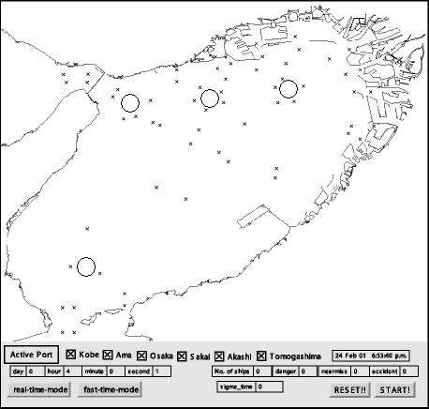
○: The rotary junction
×: Waypoint

Fig. 1. Rotary junctions and waypoints in Osaka Bay

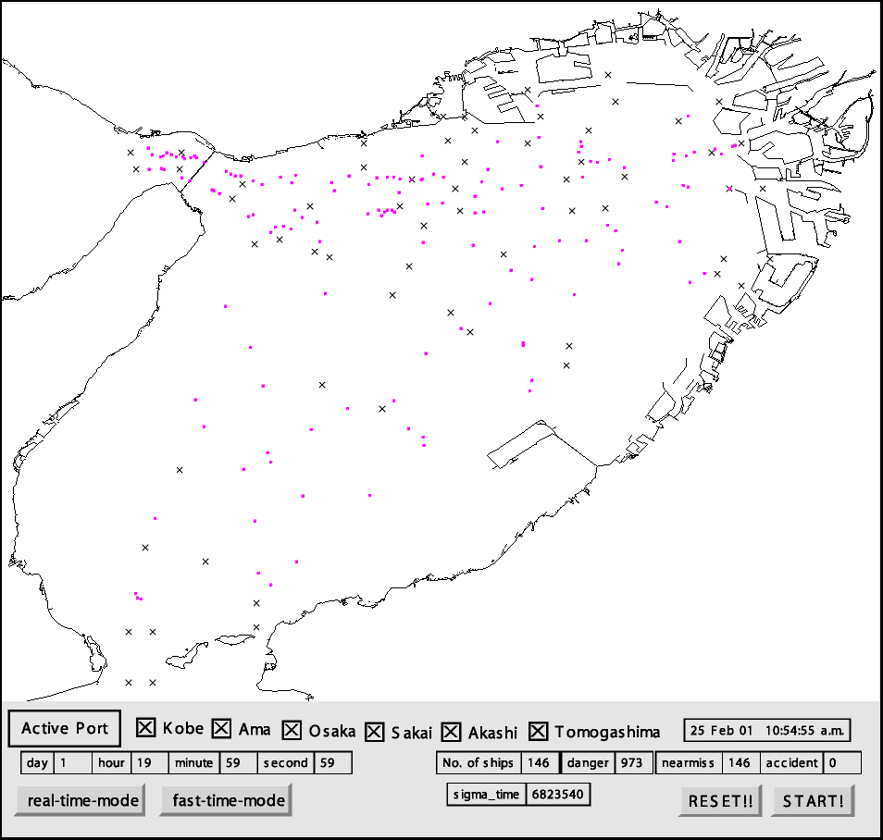
・: Ship
×: Waypoint
Fig. 2. Snapshot of Marine Traffic Flow Simulation for present condition in Osaka Bay

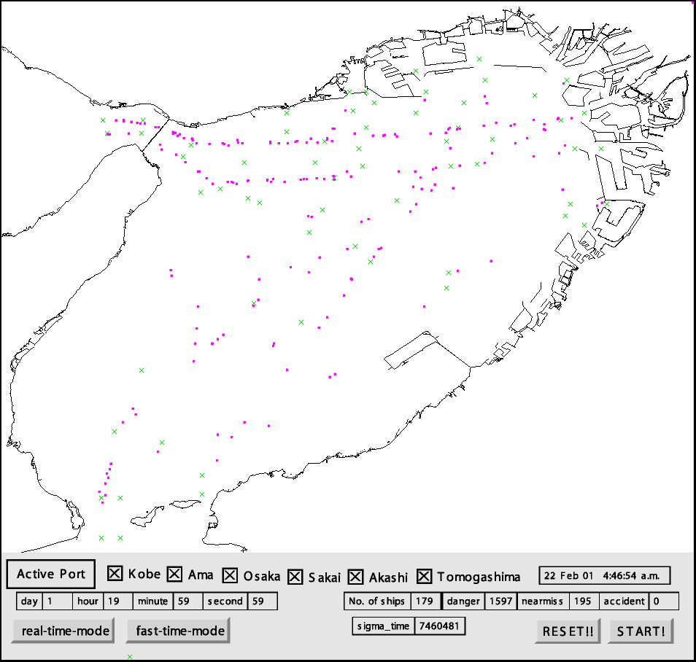
・: Ship
×: Waypoint
Fig. 3. Snapshot of Marine Traffic Flow Simulation for rotary system in Osaka Bay
・: Ship
×: Waypoint

3.2 New navigation supporting system
New concept of navigation supporting system was proposed by Hasgawa (Hasegawa, 1997[11], 1998[12], 1999[13] and 2000[14]). It is called ‘Virtual VTS (Vessel Traffic Service)’, ‘Internet Radar’ or ‘Virtual Radar’. It combines GPS and Internet. Each ship reports her position etc. to a server. The server will hold all database of reported vessels. In the return of getting data, the server will report the data of her ‘neighbours’ to the vessel. Thus each reporting vessel will get information of her neighbour vessels. Normally this is done by radar. However, it is difficult to get the data behind obstacles such as islands or bridges. The virtual radar can show even such data and it is quite important that it shows the intention or path schedule of neighbour vessels. As vessels have no winkers, it is quite important to know whether they will change course or not. In this paper, we have combined the proposal with AIS (Universal Automatic Identification System). It is a kind of VHF communication system on which packets of ship information was transmitted automatically. The original purpose of AIS was for rescue, but now it is promising for this kind of safety aids.

Each ship sends her ship ID, position, speed, heading angle, scheduled route etc. to the server. The system was checked on PC simulation. Any PC (regarded as a vessel) can send her data through Internet via home page by CGI interface. The data sent to the server will be added to the Intelligent Marine Traffic Simulator. Then the PC is treated as a vessel in the system. The other vessel data was automatically created by the simulator, so the PC will receive virtual ships’ data around her. Clicking a ship on the screen, her ID, speed, length, position, heading angle, and scheduled route etc. are displayed. Fig.5 shows the PC display. On the left side of the screen, the center of the circles is own ship and other dots denote neighbour ships. Some lines are scheduled routes of ships. On the right hand side, the information of the own ship and the clicked ship are displayed. It will prevent unnecessary collision avoidance manoeuvres or predict unexpected avoidance manoeuvres, if the target ship will change course.
Fig. 5. The virtual radar screen

In this system, the numbers of ‘danger’, ‘near miss’ and ‘accident’ judging were examined in comparison with the case of present condition. Both the numbers of ‘danger’ and ‘near miss’ decreased about 10% as compared with the present condition. The number of ‘accident’ was 0 in both of simulations. These results indicate that a ship can navigate having effective avoidance by knowing the scheduled route of other ships. Fig. 6s shows the point where the ‘near miss’ occurred for present condition (upper) and with virtual radar (lower).

The Intelligent Marine Traffic Simulator can be used effectively also for this case. It is expected to be useful for other various applications such as training, education, casualties analysis etc. If the real VTS (Vessel Traffic Service) can send data to this system, such data of non-AIS equipped ships can be also collected, because it can create data from its radar image.

Fig. 6 The points of ‘near miss’ occurred (upper: the present condition, lower: with virtual radar)

- CONCLUSIONS

Two examples of the practical use of the Intelligent Marine Traffic Simulator were introduced The first application is used for the evaluation of alternative route plan in Osaka Bay sea area. The second application is the evaluation of a new navigation supporting system. The main conclusions will be drawn as follows.

- If the rotary route paln was adopted, the numbers of ‘danger’ and ‘near miss’ increase about 40% and 30% respectively in comparison with the present condition.
- If the virtual radar system was adopted as a navigation supporting system, the numbers of ‘danger’ and ‘near miss’ decrease about 10% in comparison with the present condition.

The following can be also drawn as to the Intelligent Marine Traffic Simulator.
- The Intelligent Marine Traffic Simulator is essential tool for new route planning or navigating system evaluation.
- Combining with client PCs, the applicability of the Intelligent Marine Traffic Simulator expands quite much.
- It will be not only simulation tool, but may be installed in the real system as virtual VTS..

Future problems to be solved are as follows:
- To improve calculation speed
- To provide cheaper communication tool available on board.
- To provide cheaper and more precise GPS..

The authors sincerely acknowledge for the financial support of MLIT and Grand-in-Aids for Scientific Research of Japan Society of the Promotion of Science (JSPS).

5. REFERENCES

- Ludmann, J. D. Neunzig, M. Weilkes: Traffic simulation with consideration of driver models, theory andeExamples, http://www.ika.rwth-aachen. de/publikat/jl-eurom/jl-eurom.htm.
- Final report of research on investigation of Long-term marine traffic system in Osaka Bay (OTS 21), Kobe Marine Casualties Prevention Institute, 1989
- Third District Port Construction Bureau. The report on ship’s navigation status in Osaka Bay (in Japanese). Third District Port Construction Bureau, Ministry of Transport, Japan. Kobe. 1980
- Center for Environmental Care of Broad Coastal Area in Osaka Bay. The report on navigation status (in Japan). Center for Environmental Care of Broad Coastal Area in Osaka Bay. Osaka. 1983
- Japan Hydrographic Association. Information on sea traffic (in Japanese). Japan Hydrographic Association. Tokyo.
- Safety Navigation Forum, Hanshin Branch, Japan Captains’ Association. Information on sea traffic (in Japanese). Japan Captains’ Association. Tokyo. 1985
- Inoue, K., S. Usami and T. Shibata: Modelling of Mariner’s Senses on Minimum Passing Distance between Ships in Harbour、The Journal of Japan Institute of Navigation,Vol 90,1994,PP297-305
- Ships’ Routing (Sixth Edition) (1991). IMO
- Hasegawa, K.: An intelligent marine traffic evaluation system for harbour and waterway designs. Proc of 4th International Symposium on Marine Engineering Kobe ’90 (ISME KOBE ’90), 1990, pp.G-1-7-14
- Hasegawa, K.: Knowledge-based automatic navigation system for harbour manoeuvring. Proc. of Tenth Ship Control Systems Symposium2, 1993, pp.67-90
- Hasegawa, K.: A proposal of global ship information system and its application to automatic ship collision avoidance system. Proc. of Eleventh Ship Control Systems Symposium2, 1997, pp.197-210
- Hasegawa, K. and K. Taniguchi.: Internet radar and virtual vessel traffic service. Proc. of 2nd Conf. For New Ship Marine Technology into the 21st Century, 1998, pp.336-339
- Hasegawa, K.: Internet radar and intelligent vessel traffic service. 14th IFAC World Congress p. oral presentation, 1999
- Hasegawa, K., Y. Shigemori and Y. Ichiyama: Feasibility study on intelligent marine traffic system. Proc of 5th IFAC Conference on Manoeurvring and Control of Marine Craft MCMC2000, 2000, pp.327-332

